Zachry Event Management System

Zachry Engineering Education Complex (ZACH)

College of Engineering, Texas A&M University

Quick Reference Guide

Note: There are a few differences in the menu and navigation when you access the web site on a desktop versus when you access the responsive web site on a mobile device. We are working with the vendor to resolve some of the issues we had identified during our acceptance testing. Given below screenshots are from the desktop interface.

Login
- Go to the short URL tx.ag/ZachryEMS which will redirect you to https://coe-ems-web01.engr.tamu.edu/emswebapp/
- Login to CAS using your NetID credentials.

Browse Events and Locations
- On the left menu, under ‘BROWSE’ click ‘EVENTS’.
- The page displays events in a daily, weekly, or monthly view.
- On the left menu, under ‘BROWSE’ click ‘LOCATIONS’.
- Explore buildings and booked space.
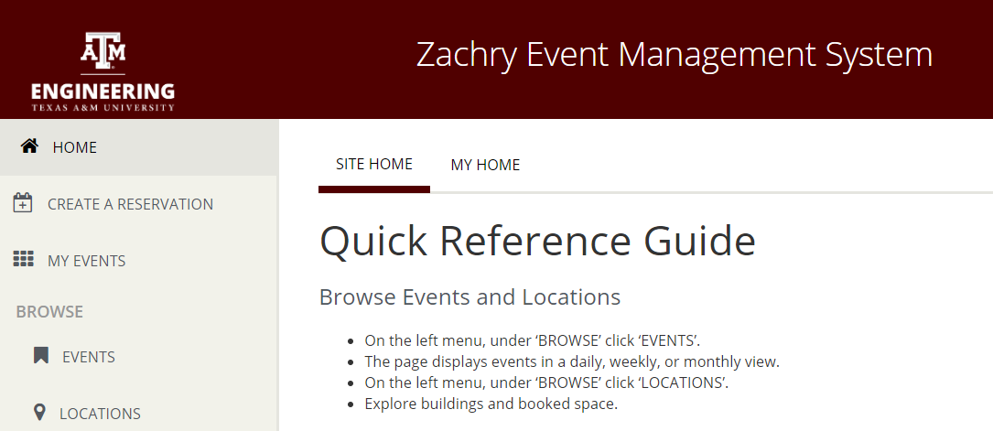
Figure 1

Create a Reservation
- On the left menu, click on the ‘CREATE A RESERVATION’, and under ‘My Reservation Templates’ select the template and click on the ‘book now’ button.
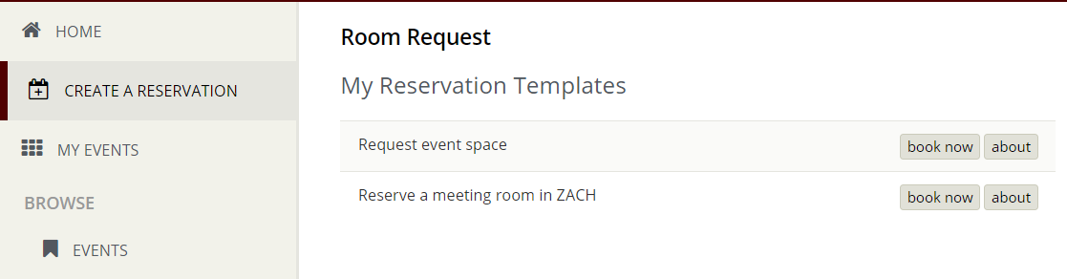
Figure 2
- On the left menu, select date and time.
- On the left menu, ‘Search’ for a room or if you know the room you want, ‘Search’ by Room Name.
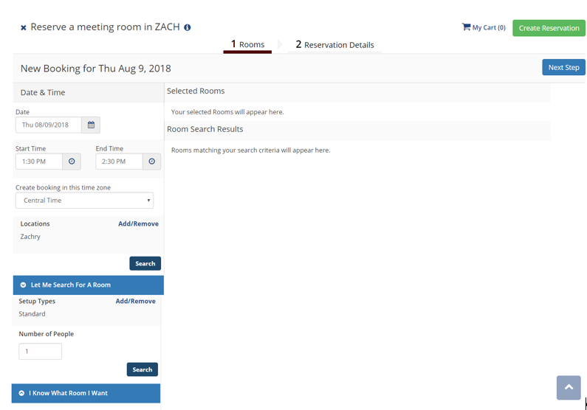
Figure 3
- Click on the ‘+’ sign beside the Room Code link to select the room.
On a desktop, Room Code link will open up a popup interface to show the room details.
Note:
On a mobile device, click on the Room Code link to select the room.
On a mobile device, click on the ‘i’ icon to show the room details.
- On the popup interface, enter the number of attendees and select the ‘Setup Type’.
- Click on ‘Add Room’ button.
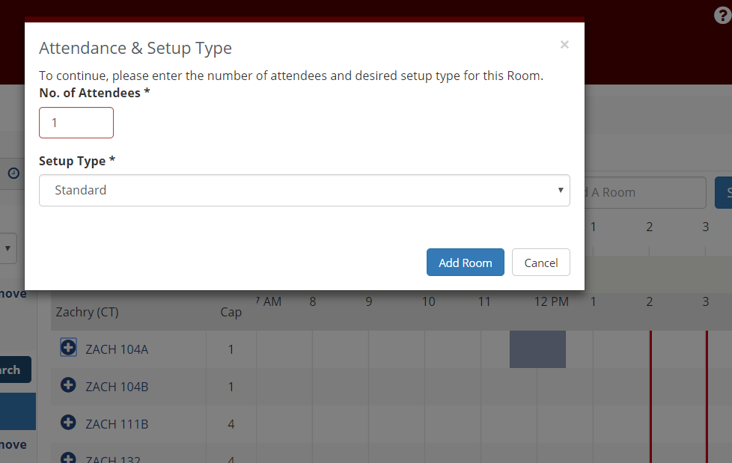
Figure 4
- Click on ‘Reservation Details’ tab or click on ‘Next Step’ button and fill in the required fields and click the ‘Create a Reservation’ button.
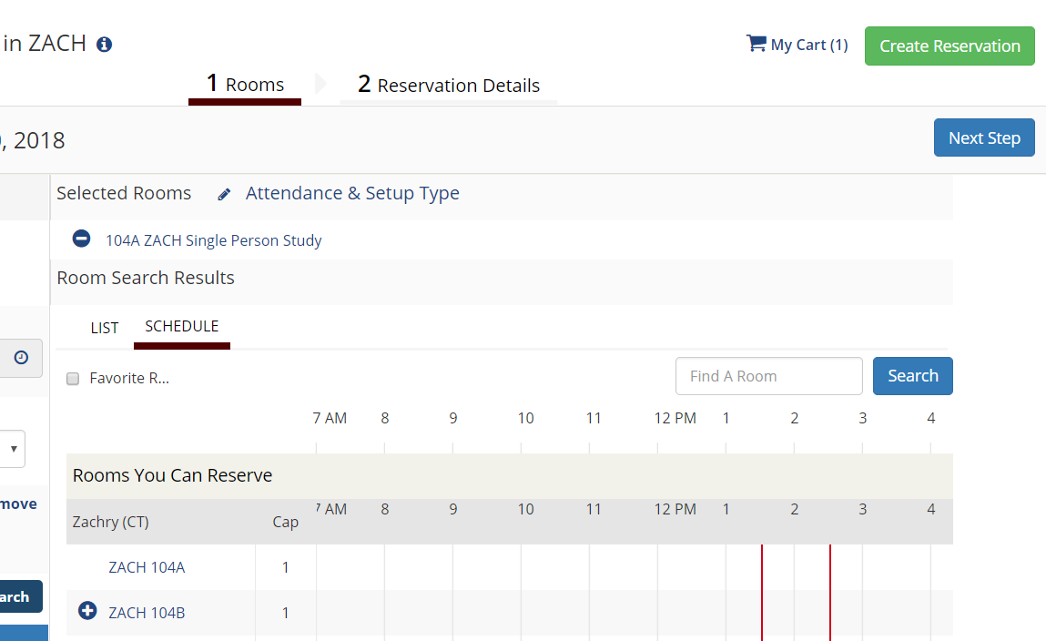
Figure 5
- If you add 1st contact information, the 1st contact will be listed as an additional host for your reservation.
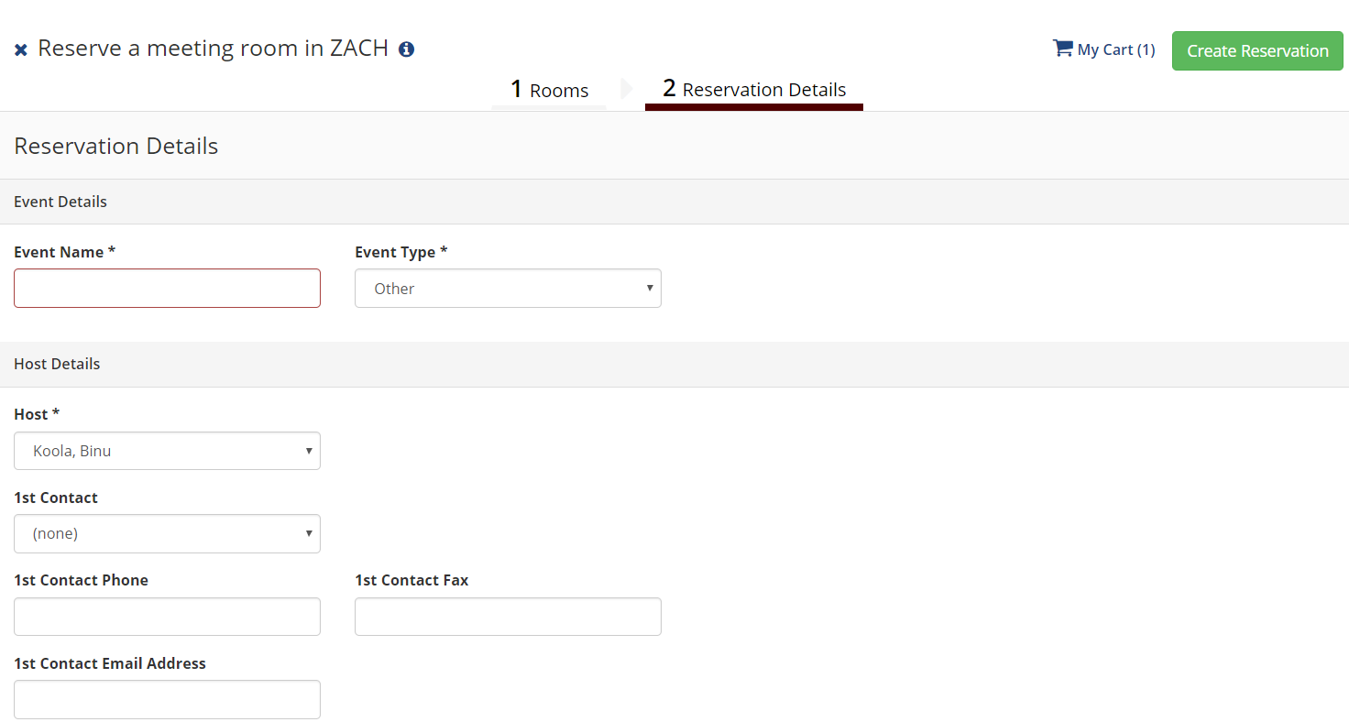
Figure 6
- You and the additional host will receive an email with ‘Subject’ as ‘Request Summary’ with ‘From’ address as ‘Zachry Event Management System’ with details about the reservation.
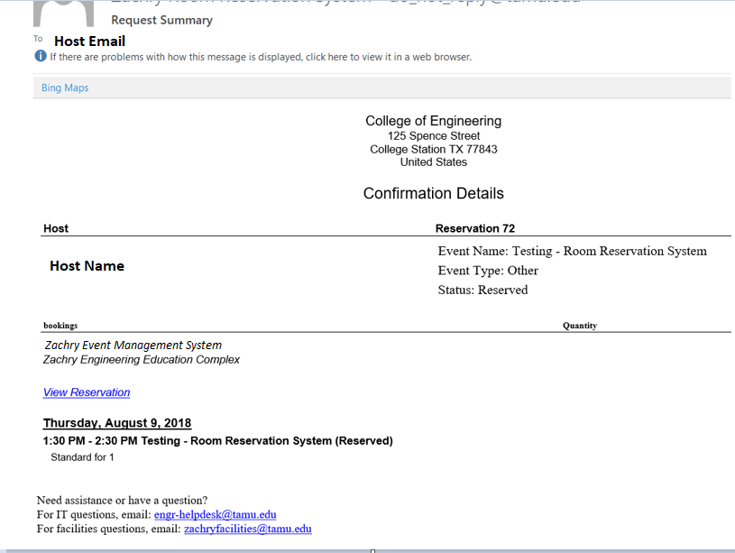Figure 7

Cancel a Reservation
- On the left menu, click on the ‘MY EVENTS’. Under the default ‘RESERVATIONS ‘ tab and under ‘CURRENT’ tab, click on the Event Name link
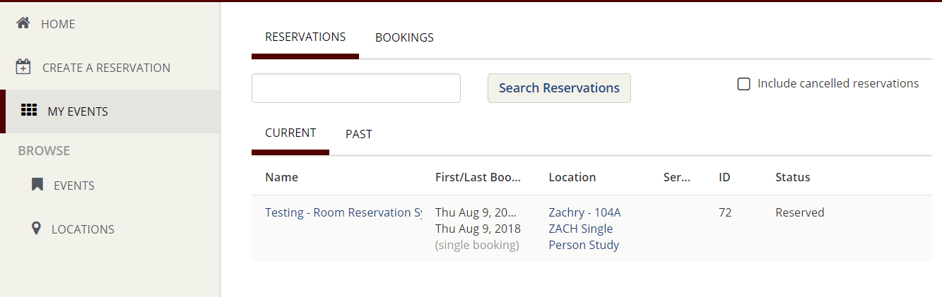
Figure 8
- Under ‘Reservation Tasks’ on the right side click on ‘x Cancel Reservation’ link.
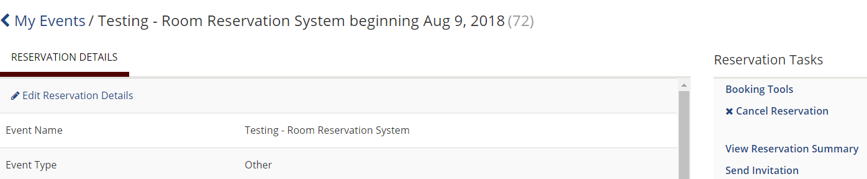
Figure 9
- On the popup interface, select the ‘Cancel Reason’ from the drop down list.
- ‘Cancel Notes’ is optional.
- Click on the ‘Yes, Cancel Reservation’ button.
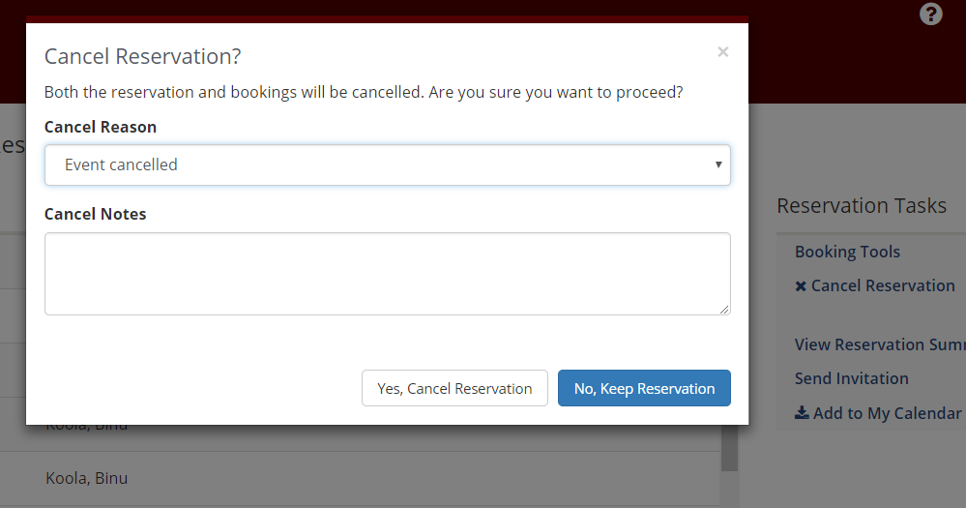
Figure 10
- You and the additional host (1st contact) if selected at the time of reservation will receive an email with ‘Subject’ as ‘Request Summary’ with ‘From’ address as ‘Zachry Event Management System’ with the cancellation reason.
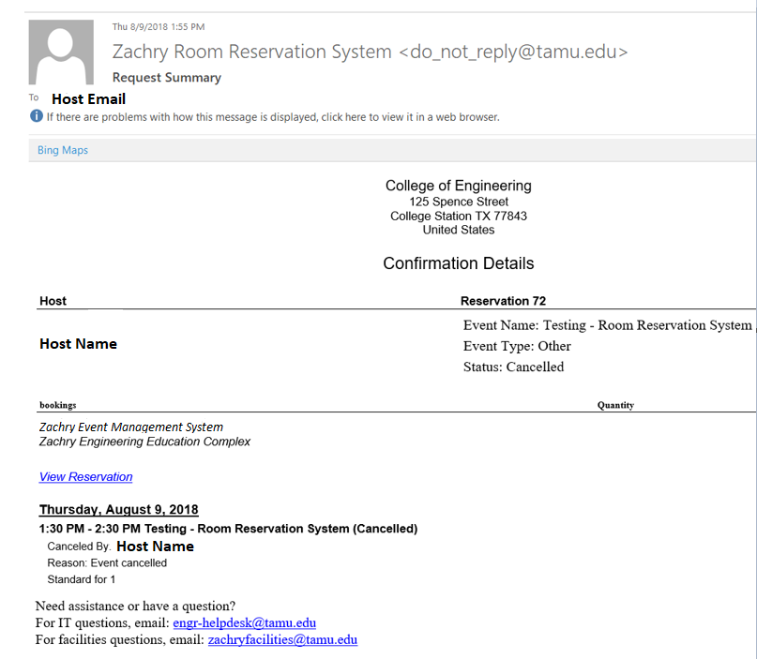
Figure 11

Edit a Reservation
- On the left menu, click on the ‘MY EVENTS’. Under the default ‘RESERVATIONS ‘ tab and under ‘CURRENT’ tab, click on the Event Name link
Note:
This functionality is currently unavailable on mobile devices.
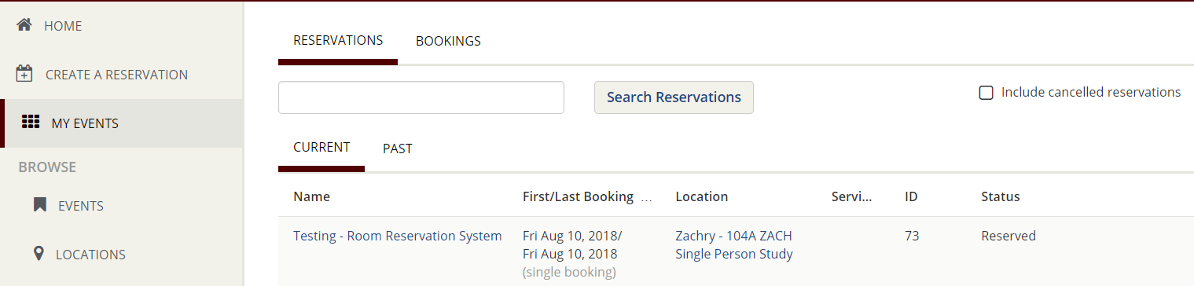
Figure 12
- Under ‘RESERVATION DETAILS’ tab click on ‘Edit Reservation Details’ link.
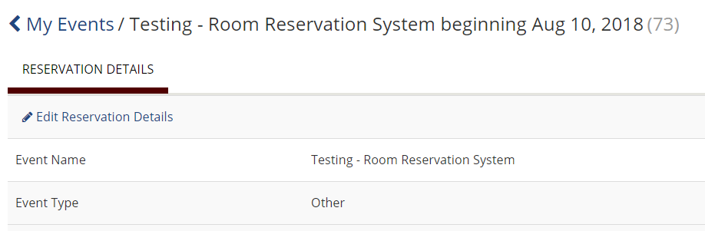
Figure 13
- Make the necessary changes and click on ‘Save Reservation Details’ button.
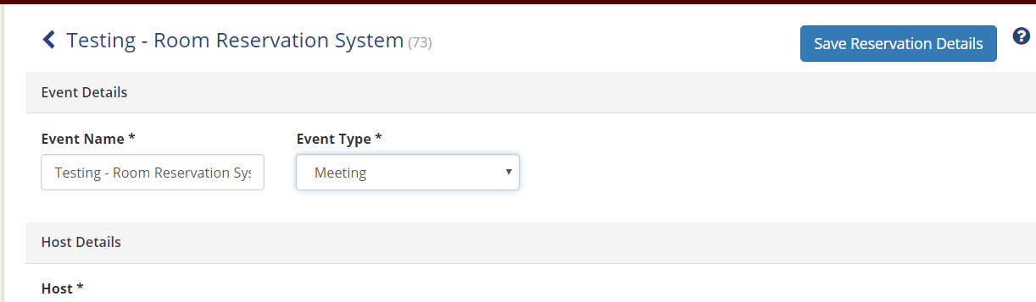
Figure 14

OR
- As soon as you create a reservation, you will be directed to the page with header ‘Reservation Created’. Click on the ‘Edit this Reservation’ link.
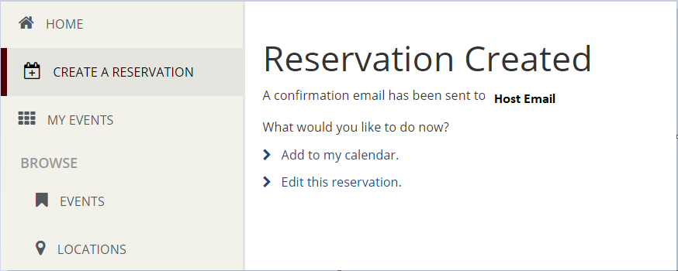
Figure 15
- Under ‘RESERVATION DETAILS’ tab click on ‘Edit Reservation Details’ link.
Figure 16

- Make the necessary changes and click on ‘Save Reservation Details’ button.
Figure 17

Edit a booking
- On the left menu, click on the ‘MY EVENTS’. on the ‘MY EVENTS’. Under the default ‘RESERVATIONS ‘ tab and under ‘CURRENT’ tab, click on the Event Name link
Figure 18
- Under ‘Bookings’ section and under ‘CURRENT’ tab click on ‘Booking Tools’ link.
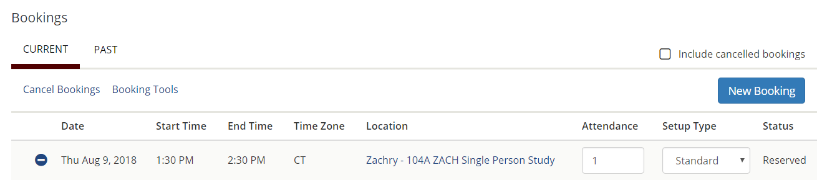
Figure 19
- Make the necessary changes and click on ‘Update Bookings’ button.
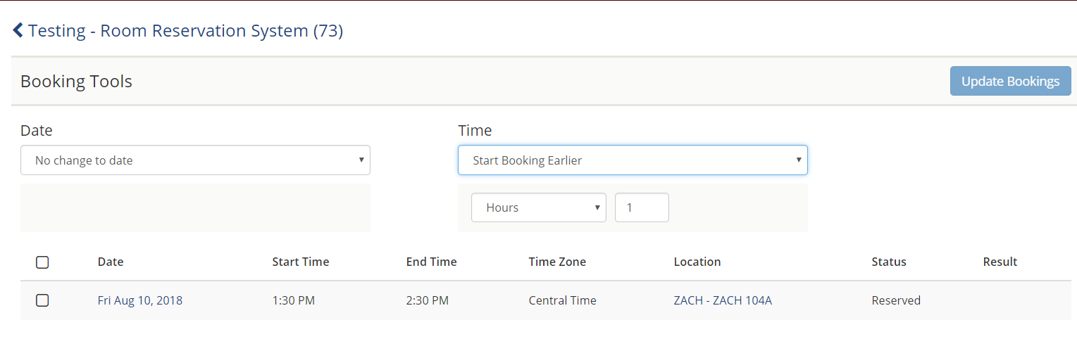
Figure 20
- You and the additional host (1st contact) if selected at the time of reservation will receive an email with ‘Subject’ containing Room Name and Event Name with ‘From’ address as ‘noreply@tamu.edu’ with details about the change in reservation.

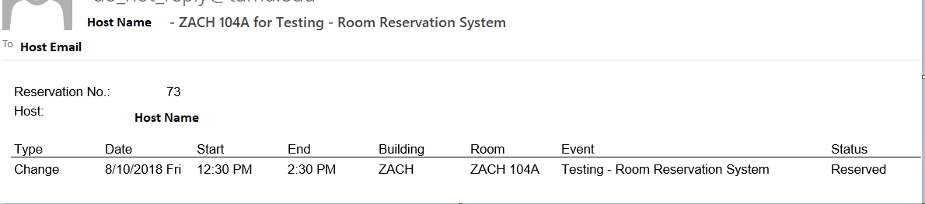
Figure 21

